Use the image below for assistance

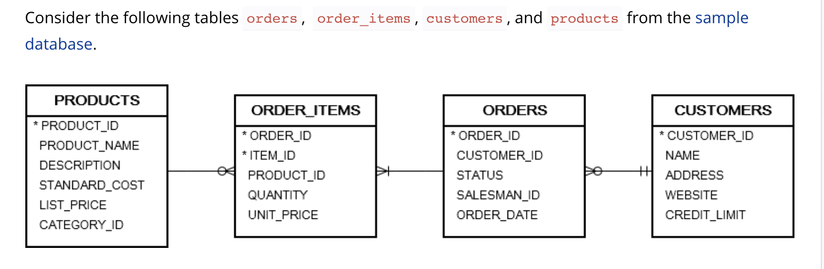
Before beginning. Provide the 2 different syntaxs for inner joins

1)List primary keys for tables and where they exist as foreign keys

Table Name:
Primary Key:
Table Names where the Primary Key exists as a Foreign Key:

Table Name:
Primary Key:
Table Names where the Primary Key exists as a Foreign Key:

Table Name:
Primary Key:
Table Names where the Primary Key exists as a Foreign Key:

Table Name:
Primary Key:
Table Names where the Primary Key exists as a Foreign Key:

2)Provide an inner join for the following:
Give me Product_names and their respective Order_IDs by joining Products and Order_items

Provide the same join in another way with different syntax

3)Provide an inner join for the following:
Give me the Salesman_id, status, order_id and Product_id by joining Orders and Order_Items

Provide the same join in another way with different syntax

4)Triple Join: Provide an inner Join with the following information:
Customer Names, Customer_ID, Status, Order_Id, and Product_Id from the following tables:
Order_items,Orders,customers

5)If you were able to do #4....take a chance on 4 tables!

Give me everything from Question 4 plus the additional information :
Product_name and Description from Products

Extra: Add a where clause to show only shipped products

Left join:

6)Give me all product_id,product_name and order_id
from products and order_items also order by order id desc

Note: You should have some nulls. (Products which have never been sold)

- Prove out number 6 using a subquery and IN statement

Right Join:

8)Get the same results from number 6 by using a right join

